Restoration Of Technical Parameters and Properties Of Used Motor Oils
Abdubannopov R.M., Kadirov X.I., Sodikov U.X.
Department of Chemical Technology of Oil and Gas Processing, Tashkent Institute of Chemical Technology, Navoi Street 36, Tashkent
100011, Uzbekistan
Kadirov X.I
Sodikov U.X.
Abdubannopov R.M adubannopovraxmatillo@gmail.com
Abstract. Used motor oils contain oxidation products, suspended solids, degraded additives and metal-containing wear debris. This study evaluates a two-stage regeneration route combining acetone/sulfuric-acid pretreatment with adsorption on activated Navbakhor bentonite, modified Tebinbulak vermiculite and their composite. Process variables included treatment time, reagent ratio, settling time and temperature. X-ray diffraction, gas chromatography-mass spectrometry, elemental analysis and standard physicochemical tests were used to assess the process.
The bentonite-vermiculite composite gave the best overall performance. At the optimum acetone:used-oil ratio of 30:70 and approximately 53 °C, the maximum purification efficiency was 92 %. For two independent oil samples, mechanical impurities decreased from 0.0795 ± 0.0106 % to 0.0195 ± 0.0049 %, while Pb, Zn and Cr concentrations decreased to 0.935 ± 0.064, 139.62 ± 1.94 and 2.535 ± 0.502 mg/kg, respectively. The regenerated oil approached the properties of fresh oil; however, the flash point and pour point remained below the selected GOST benchmark, indicating that blending and additive adjustment are required before reuse.
The proposed process provides a practical route for reducing hazardous lubricant waste while using locally available mineral adsorbents.
Keywords: used motor oil; regeneration; activated bentonite; modified vermiculite; adsorption; waste-oil recycling
1. Introduction
The growth of road transport has increased lubricant consumption and the generation of used motor oils. During service, lubricants accumulate oxidation products, degraded hydrocarbons, soot, water and metal-containing wear particles that create environmental and operational risks [1-4]. Mineral and synthetic base oils differ in molecular-size distribution, as schematically illustrated in Figures 1 and 2 [5].
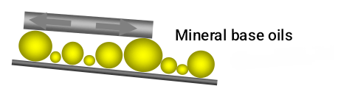 | 
Figure 1: Schematic of lubricating properties of mineral base oils (molecules of various sizes) | Figure 2: Schematic of lubricating properties of synthetic base oils (molecules of uniform size)
Regeneration is preferable to uncontrolled disposal or low-grade combustion because it conserves petroleum resources and reduces hazardous waste [6-9]. Recent Chemical Engineering Transactions studies have also demonstrated the relevance of separation, adsorption and catalytic routes for waste-oil treatment and valorisation [10-12].
This work investigates activated Navbakhor bentonite, modified Tebinbulak vermiculite and their composite for regenerating used motor oil. The objective was to determine suitable pretreatment and adsorption conditions and to compare the regenerated product with fresh commercial oil and selected GOST requirements.
2. Materials and Methods
Used motor oil was collected from automotive service stations. Bentonite from the Navbakhor deposit (Navoi Region, Uzbekistan) and vermiculite from the Tebinbulak deposit (Republic of Karakalpakstan, Uzbekistan) were purified, dried, milled and activated before use.
The regeneration route comprised two stages. First, the oil was filtered and subjected to thermal treatment, sulfuric-acid treatment and acetone extraction to remove water, sludge, resins and suspended impurities. Second, the pretreated oil was passed through activated bentonite, modified vermiculite or the bentonite-vermiculite composite.
Adsorbents were characterised by X-ray diffraction (XRD). Changes in oil composition were evaluated by gas chromatography-mass spectrometry (GC-MS) and elemental analysis. The main response was purification efficiency, supported by changes in viscosity, mechanical impurities, flash point, pour point, density, water and metal concentrations.
Kinematic viscosity was measured according to GOST 33-2000, mechanical impurities according to GOST 6370-83, flash point according to GOST 6356-75, pour point according to GOST 20287-91, density according to GOST 3900 and water content according to ASTM E2412-10.
The investigated variables were acetone extraction time, acetone:oil ratio, sulfuric-acid concentration, settling time and treatment temperature. Two independent oil samples were available. Duplicate oil data are therefore reported as mean ± sample standard deviation (SD, n = 2); no inferential statistical test was applied because the sample size was insufficient. Tables 1 and 2 contain single reported mineral-characterisation values, so an SD was not fabricated.
Acetone extraction was studied for up to 5 h and sulfuric-acid treatment for 8-12 h. The influence of treatment duration is presented in Figure 3, while reagent ratios and operating temperatures are compared in Figure 4.
At 24 °C, increasing the acetone fraction improved phase separation. The strongest response was obtained after approximately 45-60 min of settling (Figure 5).
The subsequent temperature and settling-time experiments were used to identify the operating window shown in Figures 6 and 7.
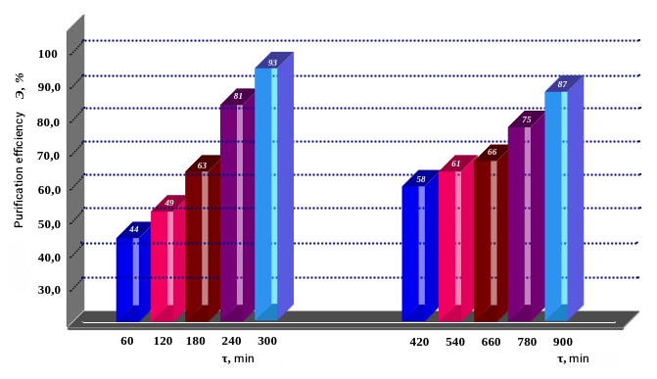 | 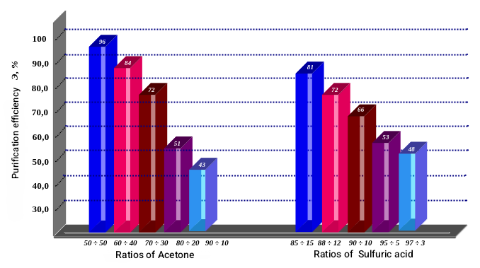
Figure 3: Purification efficiency as a function of treatment duration in acetone (1-5 h) and H₂SO₄ (8-12 h) | Figure 4: Purification efficiency at different acetone ratios (28 °C) and sulfuric-acid ratios (70 °C)
At 24 °C, purification efficiency increased with the acetone fraction and approached a plateau after 45-60 min. Figure 5 summarises the effect of settling duration for the investigated acetone:used-oil ratios.
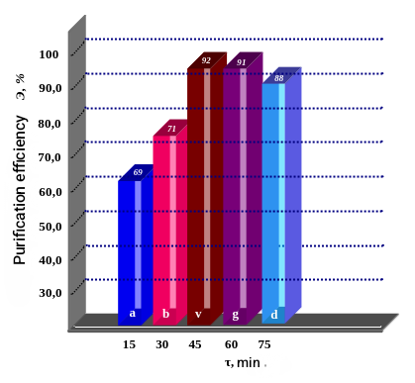

Figure 5: Purification efficiency as a function of settling duration at acetone:used-oil ratios of 10:90, 20:80, 30:70, 40:60 and 50:50 (24 °C)
The temperature effect is shown in Figure 6. Purification efficiency increased to a maximum of approximately 92 % near 53 °C for the 30:70 acetone:used-oil ratio and declined above 55 °C, most likely because of increased acetone volatilisation (Figure 6).
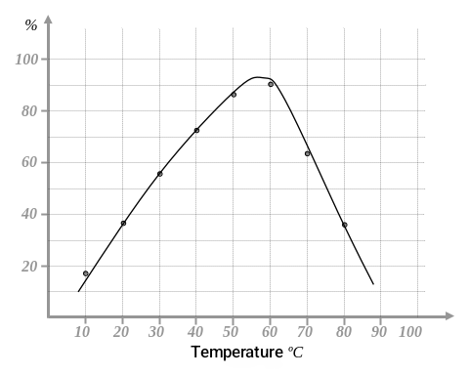
Figure 6: Purification efficiency as a function of temperature for an acetone:used-oil ratio of 30:70
The influence of settling time under the five concentration conditions is presented in Figure 7. The curves approached their plateaus after approximately 60-80 min, whereas the fastest condition reached its maximum within about 10-15 min (Figure 7).
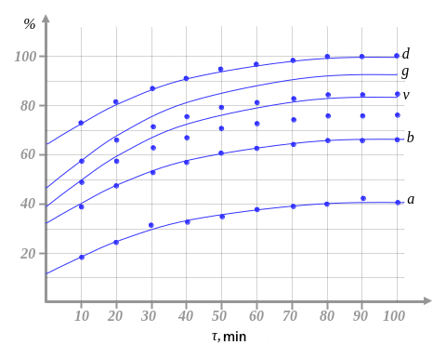
Figure 7: Purification efficiency as a function of settling time under the five concentration conditions investigated
3. Results and Discussion
After solvent treatment, the oil was filtered and subjected to adsorption purification. Acid-base and thermal activation of bentonite and vermiculite increased the relative SiO₂ content and improved oil flow through the adsorbent bed.
Acid treatment of expanded Tebinbulak vermiculite dissolved part of the Mg-, Fe- and Al-containing phases. The measured changes in bulk composition and textural properties are summarised in Tables 1 and 2.
Increasing the HNO₃:H₂SO₄ treatment ratio raised the measured SiO₂ fraction from 60.3 % to 72.2 % and reduced MgO from 3.2 % to 1.1 % (Table 1).
Table 1: Effect of nitric/sulfuric-acid treatment on vermiculite composition
HNO₃:H₂SO₄ ratio | Content, % of dry matter
HNO₃:H₂SO₄ ratio | SiO₂ | Al₂O₃ | Fe₂O₃+FeO | CaO | MgO | Na₂O | K₂O | P₂O₅ | SO₃ | CO₂ | H₂O
0 | 60.3 | 16.8 | 6.6 | 1.1 | 3.2 | 3.6 | 2.4 | 0.2 | 0.3 | 0.1 | 9.2
5:5 | 68.8 | 10.11 | 5.4 | 0.7 | 1.9 | 2.06 | 1.24 | 0.1 | 0.2 | 0.06 | 6.7
10:10 | 72.2 | 0.08 | 2.8 | 1.2 | 1.1 | 0.05 | 2.94 | — | 0.06 | 13.1 | —
The 10:10 treatment produced the highest SiO₂ fraction, whereas the 5:5 condition provided a more balanced combination of density, specific volume and sorption behaviour. Because these values are single reported measurements, they should not be interpreted as statistically significant differences.
Table 2: Effect of acid-mixture ratio on vermiculite textural and sorption properties
HNO₃:H₂SO₄ ratio | Specific volume, Å | Sorption, mg/g |  | Density, g/cm³ | Water (TGA), % | Micropore surface, m²/g | Micropore volume, cm³/g
HNO₃:H₂SO₄ ratio | Specific volume, Å | Base | Acid
0 | 281.0 | 35.4 | 7.21 | 1.602 | 0.178 | 1.27 | 0.017
2:2 | 237.1 | 47.9 | 4.03 | 1.441 | 0.471 | 2.19 | 0.022
5:5 | 211.5 | 80.3 | 1.40 | 1.251 | 0.849 | 3.52 | 0.029
8:8 | 247.2 | 101.5 | 1.92 | 1.277 | 0.697 | 4.97 | 0.038
10:10 | 271.5 | 174.0 | 2.11 | 1.298 | 0.506 | 6.34 | 0.042
Low acid concentrations produced limited changes, whereas stronger activation increased micropore surface area and volume. On the basis of the combined properties, the 5:5 ratio and a treatment time of 60-90 min were selected for subsequent work.
The XRD pattern of acid-activated Tebinbulak vermiculite is shown in Figure 8.
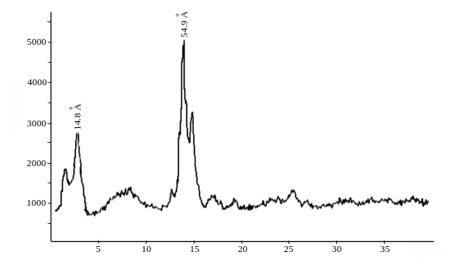
Figure 8: X-ray diffractogram of acid-activated Tebinbulak vermiculite
The diffractogram contains basal reflections near 11.8 and 5.49 Å. These features are consistent with a layered vermiculite/chlorite-type material, but definitive phase identification requires comparison with reference patterns; therefore, the mineral assignment should be regarded as tentative.
Zn(II) sorption was higher for the acid-activated material than for untreated vermiculite (Figure 9), indicating that activation exposed additional sorption sites and pore volume.
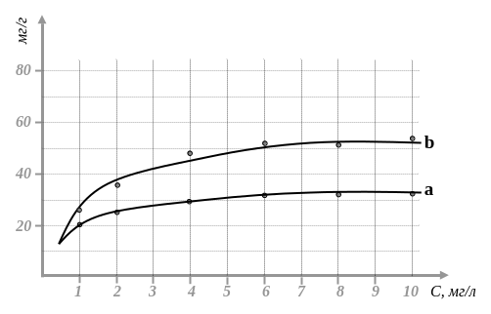
Figure 9: Zn(II) sorption isotherms for untreated (a) and acid-activated (b) vermiculite
Surface modification was also studied with pyridine at vermiculite:pyridine ratios of 1:2-1:4, temperatures of 80-100 °C and contact times of 8-24 h. Heating to 80-90 °C reduced the interlayer distance from 15.43 to 14.78 Å.
The combined sorbent is expected to retain metal ions through cation exchange on negatively charged surfaces and inner-sphere complexation at active sites. The elemental composition of the two used-oil samples is reported in Table 3.
Table 3: Elemental analysis of two used-motor-oil samples
Sample No. | Sampling time | Cr⁵² (mg/kg) | Zn⁶⁶ (mg/kg) | Cd¹¹¹ (mg/kg) | Ba¹³⁷ (mg/kg) | Pb²⁰⁸ (mg/kg)
1 | 11.10.2022 17:23 | 4.296 | 225.557 | 0.09 | 8.17 | 9.142
2 | 19.10.2022 17:27 | 4.780 | 211.84 | 0.12 | 8.19 | 10.029
Mean ± SD  (n = 2) | — | 4.538 ± 0.342 | 218.699 ± 9.699 | 0.105 ± 0.021 | 8.180 ± 0.014 | 9.586 ± 0.627
The two samples contained measurable Cr, Zn, Cd, Ba and Pb. A contact time of 1 h was selected for the bentonite-vermiculite bed, and the resulting physicochemical properties are summarised in Table 4.
Table 4: Physicochemical properties of used, regenerated and fresh motor oils (mean ± SD, n = 2)
Property | Used oil | Regenerated oil | Fresh oil
Viscosity at 40 °C, mm²/s | 60.17 ± 0.60 | 68.39 ± 1.58 | 91.46 ± 1.07
Viscosity at 100 °C, mm²/s | 9.55 ± 0.04 | 11.70 ± 1.02 | 14.30 ± 0.43
Mechanical impurities, % | 0.0795 ± 0.0106 | 0.0195 ± 0.0049 | —
Flash point, °C | 197.5 ± 10.6 | 211.0 ± 8.5 | 204.0 ± 5.7
Pour point, °C | −22.5 ± 0.7 | −29.5 ± 0.7 | −40.0 ± 0.0
Density, kg/m³ | 881.0 ± 1.4 | 876.0 ± 1.4 | 862.2 ± 1.1
Sulfur, mg/kg | 0.3340 ± 0.0144 | 0.2294 ± 0.0195 | 0.2204 ± 0.0153
Lead, mg/kg | 15.93 ± 7.40 | 0.935 ± 0.064 | 0.170 ± 0.014
Zinc, mg/kg | 395.26 ± 10.89 | 139.62 ± 1.94 | 138.61 ± 0.61
Calcium, mg/kg | 187.53 ± 22.05 | 65.48 ± 2.92 | 63.71 ± 3.07
Magnesium, mg/kg | 438.54 ± 3.42 | 123.26 ± 1.56 | 142.30 ± 31.28
Chromium, mg/kg | 13.11 ± 7.29 | 2.535 ± 0.502 | 2.70 ± 0.86
Barium, mg/kg | 8.67 ± 7.38 | 2.97 ± 2.74 | 0.905 ± 0.049
Regeneration reduced mechanical impurities and the concentrations of Pb, Zn, Ca, Mg, Cr and Ba. The regenerated oil was closer to fresh oil, but the flash point and pour point did not fully meet the selected GOST limits (Table 5). Reuse should therefore be considered only after blending, additive adjustment and confirmation by a larger replicated test programme.
Table 5: Regenerated-oil properties compared with selected standard limits
Property | Method | Selected limit | Regenerated oil  (mean ± SD, n = 2)
Kinematic viscosity at 40 °C, mm²/s | GOST 33-2000 | — | 68.39 ± 1.58
Kinematic viscosity at 100 °C, mm²/s | GOST 33-2000 | 9.3-12.5 | 11.70 ± 1.02
Mechanical impurities, % | GOST 6370-83 | < 0.2 | 0.0195 ± 0.0049
Water content, % | ASTM E2412-10 | Trace | Trace
Flash point (closed cup), °C | GOST 6356-75 | ≥ 215 | 211.0 ± 8.5
Pour point, °C | GOST 20287-91 | ≤ −40 | −29.5 ± 0.7
Density at 20 °C, kg/m³ | GOST 3900 | ≤ 890 | 876.0 ± 1.4
The proposed batch flowsheet is shown in Figure 10. It combines preliminary filtration, centrifugation, acetone washing, settling and adsorption on activated bentonite/vermiculite.
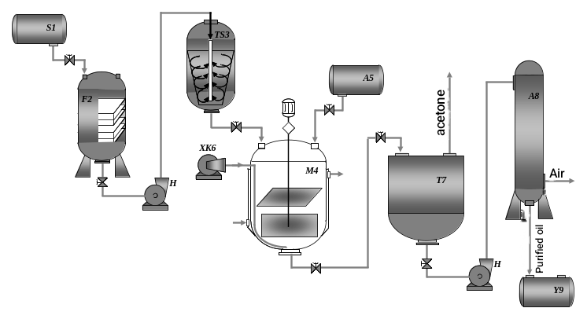
Figure 10: Combined regeneration system: S1, used-oil tank; F2, filter; TS3, centrifuge; M4, mixer; A5, acetone tank; XK6, air compressor; T7, settler; A8, adsorber; Y9, regenerated-oil tank
Used oil from S1 passes through filter F2 and centrifuge TS3. In mixer M4, the oil is contacted with acetone under compressed-air agitation for 5 h and then settled for 30-60 min in T7. The clarified phase is treated in adsorber A8. Recovered acetone is returned to the process, and regenerated oil is collected in Y9.
4. Conclusions
A two-stage process comprising acetone/sulfuric-acid pretreatment and adsorption on activated Navbakhor bentonite and modified Tebinbulak vermiculite improved the quality of used motor oil. The composite adsorbent produced the best overall purification, with a maximum reported efficiency of 92 %. Duplicate-sample analysis confirmed substantial reductions in mechanical impurities and metal contaminants. Nevertheless, the limited sample size (n = 2) and the remaining flash-point and pour-point deviations prevent an unconditional claim of full GOST compliance. Additional replicated testing, additive optimisation and engine-performance validation are required before industrial reuse.
References

- Maksimov S.A., Ryzhkov N.R., Boyko G.V., 2017, Study of motor oils and their effect on road-transport operation, Young Scientist, 14(148), 98-101.
- Sivakov V.V., Bykhovets I.D., 2014, Environmental aspects of using spent motor oil, In: Ecology and Environmental Protection: Proceedings of the International Scientific-Practical Conference, Minsk, Belarus, 23-26.
- Baltenas R., Safonov F.S., Ushakov A.I., 2000, Motor Oils, Alfa-Lab, Moscow-Saint Petersburg, Russia.
- Bogomolov A.I., Gaile A.A., Gromova V.V., 1989, Chemistry of Petroleum and Gas, Khimiya, Leningrad, Russia.
- Kuznetsov A.V., 2007, Fuel and Lubricants, Kolos S, Moscow, Russia.
- Yuzefovich V.I., 2003, Organization of used-oil collection, World of Petroleum Products, 3, 28-30.
- Ivin Yu.F., Smolin A.N., Golenishcheva E.V., et al., 2003, Development of an installation for regeneration of used motor oils, In: New Technologies in Processing and Utilization of Used Oils and Lubricants, REFIA, Moscow, Russia, 89-90.
- Klinskiy A.V., Krasnenko A.F., Startsev A.A., 2003, Technology for regeneration of selectively collected spent technical oils, In: New Technologies in Processing and Utilization of Used Oils and Lubricants, REFIA, Moscow, Russia, 61.
- Kapustin V.M., Tonkonogov B.P., Fuks I.G., 2014, Technology of Oil Refining, Vol. 3, Khimiya, Moscow, Russia.
- Casallas I.D., Carvajal E., Mahecha E., Castrillon C., Gomez H., Lopez C., Malagon-Romero D., 2018, Pretreatment of waste cooking oils for biodiesel production, Chemical Engineering Transactions, 65, 385-390, DOI: 10.3303/CET1865065.
- Sarno M., Scudieri C., 2018, H2 production improvement during pyrolysis catalized by zeolites, Chemical Engineering Transactions, 65, 157-162, DOI: 10.3303/CET1865027.
- Razak N.A., Hanafi M.H.M., Razak N.H., Ibrahim A., Omar A.A., 2022, Characterization of waste cooking oil purified by crushed and sliced Zingiber officinale (ginger), Chemical Engineering Transactions, 94, 337-342, DOI: 10.3303/CET2294056.

